**MAAR Investments**

*Connecting Good Ideas with Better Resources*

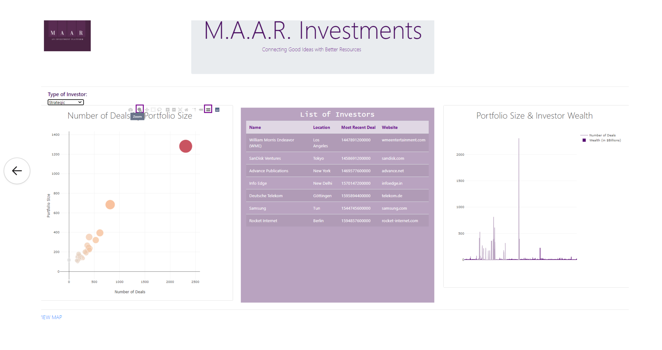

Project #2: Visualize Me, Captain!

Alissa Vokes, Arun Kara, Marianne Boerenko, Rebecca Gonzalez

UCF’s Data Analysis and Visualization

October 10, 2020

**Abstract**

            Given the plethora of small businesses in the United States, investors have a surplus of potential investment opportunities.  With the right strategy, small businesses can successfully grow their company when paired with the right investment partner.  Most will start with investing in their own business but when that runs out, the business owner can quickly go bankrupt. Finding an investor or landing a business pitch meeting with potential investment companies can take weeks, if not months, of research and networking in addition to the daily responsibilities of an entrepreneur working to keep their company afloat.  With all the possibilities out there, where should a business owner start?

Another option is finding an investment advisor.  Currently, there are approximately 13,000 registered investment advisors (RIAs) in the United States. (‘Statista’)  This option does not eliminate the need for the business owner to endure weeks of research and months of networking simply to find the right RIA.   While choosing a potential investor can seem intimidating, it only requires the right partner to narrow down the search.

Our company takes the guesswork out of the search for an investor.  We meet with our clients and visit their place of business to better determine their needs and desires. We then build a customized-interactive website of curated investors for each client to parse through at their convenience. An easily accessible and sizable investor portfolio consisting of angel investors, strategic investors, venture capitalists, and private equity investors broadens our clients outlook in a matter of hours while eliminating months of wasted research.

In the following pages, MAAR Investments will showcase why our strategy and methodology benefits the small business owner and is the right partner for our clients.

Table of Contents

1    Introduction 4

2    Background 4

2.1  The Data Sets 4

2.2  The Website 6

2.3 The Visualization 7

3   Conclusions and lessons learned 8

4    References 8

1    Introduction

The purpose of this paper is to outline the strategy and methodology of MAAR Investments.  Static visualizations give the individual one view of the data.  Our interactive visualizations allow the user to easily compare investor portfolios and make data driven decisions to meet their business needs.  By making different choices, they can view the data in a whole new way.

2    Background

MAAR Investments started as a simple college project by a group of students with a vision. It may not be on the level of Google or Facebook (yet), both started by a group of college students, but it exploits the opportunity to fill a gap for small businesses and startups.

2.1  The Data Sets

The first step for MAAR Investments was to identify the data sets that would serve as the foundation of the interactive website while fulfilling the requirements of the project.  The first data set was a rest api of investors by Mattermark. (‘Investors’)   Mattermark leverages machine learning and natural language processing to extract data from millions of news articles and websites and verifies the data daily.  While Mattermark’s data set is comprehensive, we combined it with additional data sets to give it more flexibility and fluidity for our clients.

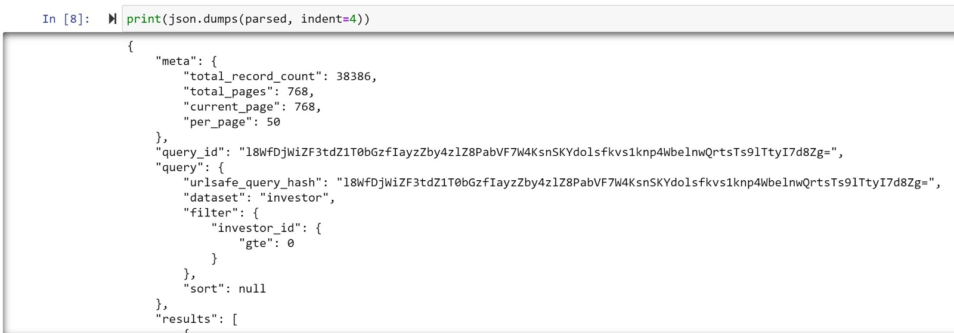

**Figure 2:  api json**

The second data set used was a list of the most influential people of the world from the Forbes List of Billionaires through Kaggle.com.(Lu)  This gives users an expansive list of potential Angel Investors. Our algorithms also consider the industry of angel investors to better align potential matches for our clients.

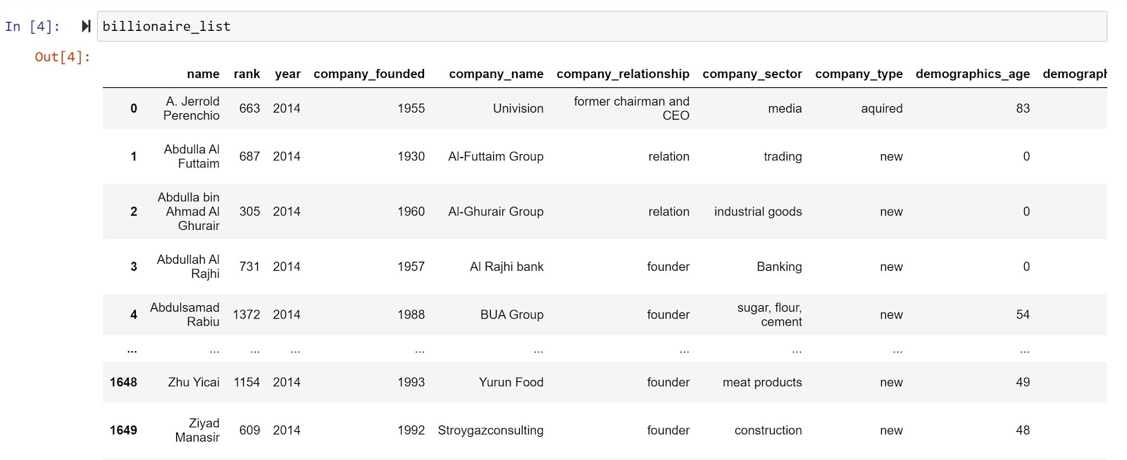

**Figure 3:  Forbes CSV**

Finally, many of our clients want to attempt to gain investors by appearing on +shows like SharkTank, the American franchise of the International format Dragons’ Den, which originated in Japan.(‘Shark Tank’)  Unfortunately, it is extremely difficult to overcome a failed presentation on live TV so we do not recommend this avenue to our clients.  However, the popularity of the show has enlisted a wide range of followers and due to popular demand, we have included its investors within this data set.

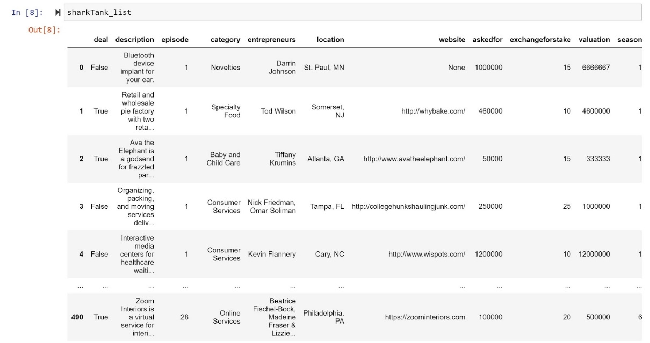

**Figure 4:  Shark Tank CSV**

By using Python to perform the api calls to the Mattermark api, the data set of 500 investors in food and beverage was combined and then saved as a csv to allow a simple process of uploading to PgAdmin 4, a management tool for Postgresql.  The Forbes List and the Shark Tank were then uploaded into PgAdmin 4.  The Entity Relationship Diagram (ERD) identified similar columns from each data set to allow us to combine the data sets into one table within Postgresql.

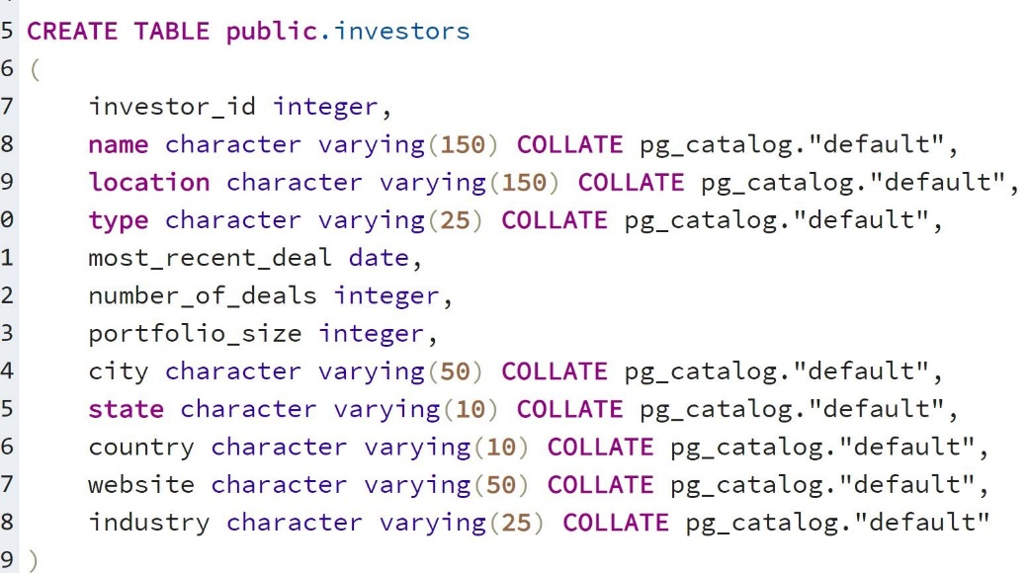

**Figure 5:  Investors Table Postgresql**

The data sets were then cleaned to ensure the quality of the data.  Columns or rows missing multiple values were removed.  Missing values needed for the final charts were researched and inserted into the data sets.  The headings of columns that were needed for the final data set were renamed so like columns could be appended.  This allowed the tables to be combined on the primary key, “name”.   Duplicate or irrelevant data was then deleted by row. Numbers stored as strings were converted to numbers. This provided a better data set that could then be used for our interactive visualizations.

2.2  The Website

The application was developed using a variety of tools:

* Javascript
  + HTML
  + CSS
  + Leaflet
  + Bootstrap
  + Jquery
  + Json
* Plotly
* Flask
* postgresql
* Heroku

Our website is built using a flask app and javascript.   A flask app provides us with tools, libraries and technologies that allow us to build a web application.  It provides the foundation of our website. We chose to use a flask app based on the project requirements and how quickly it is to set up, in theory.

Javascript allowed us to create interactive visualizations for users to be able to quickly and confidently parse through the data to find what is most meaningful to them.  We used a new javascript library from leaflet called BeautifyMarker. ("masajid390/BeautifyMarker", 2020)

2.3 The Visualization

Our first visualization is an interactive map of the different types of investors and their location.  This will allow users to identify investors locally or in locations they may wish to expand to.  Some users may prefer American companies while others will be more open to investors from any country.  When you click on the map markers you can immediately see the name of the investor and their website (if available).

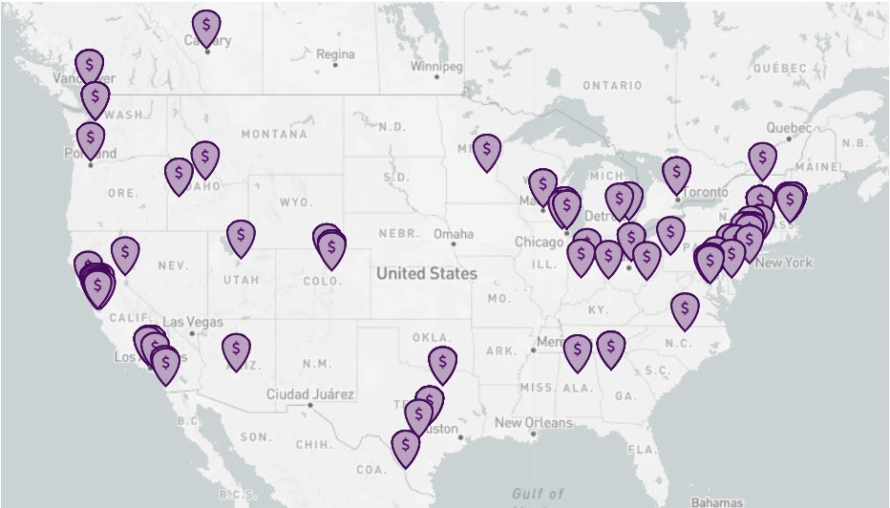

**Figure 6: Interactive Map of Investors**

Our interactive dashboard can be sorted by the type of investor: angel, strategic, venture capitalist funds, or private equity investors.  Visualizations compare the number of deals per investor, portfolio size, accumulated wealth, and average growth score. Additionally, at a glance investor information such as website domain and location are provided to clients for further research.

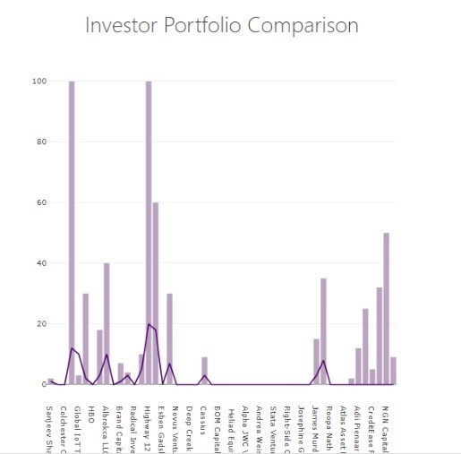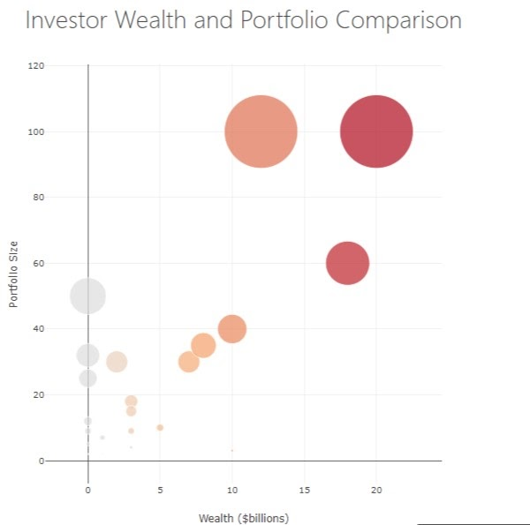

**Figure 7: Bar Chart Figure 8: Bubble Plot**

3   Conclusions and lessons learned

Our final interactive website for end users met our expectations and allowed users to tailor the views to their specific requirements. While following the technical requirements of this project, we ran into a few snags trying to put the pieces together.  We also realized that all the different pieces required for a viable and useful website cannot be created in silos.  It really took a lot of teamwork to bring the final product together.  As a first step to providing a tool to investors, this project created a great foundation for future enhancements.

4    References

Atyourbusiness.com. 2020. *8 Best Investment Strategies For Small Business Owners*. [online] Available at: <http://www.atyourbusiness.com/blog/a-sound-investment-8-best-investment-strategies-for-small-business-owners/> [Accessed 8 October 2020].

Statista. 2020. *Number Of Rias Employed In The U.S. 2019 | Statista*. [online] Available at: <https://www.statista.com/statistics/614815/number-of-rias-employed-usa/#:~:text=In%202019%2C%20there%20were%2012%2C993,state%20in%20which%20they%20practice.> [Accessed 8 October 2020].

Guillaume, L., Oracles, T., Robinson, R., Connor, T., Cravatt, B., Jose, S., Cravatt, B., Morgan, E., Brogie, M., Bernstein, R. and Bernstein, R., 2020. *5 Types Of Investors For Startups*. [online] StartupNation. Available at: <https://startupnation.com/sponsored-content/types-investors-startups/> [Accessed 8 October 2020].

Unwin, Antony. “Why Is Data Visualization Important? What Is Important in Data Visualization? · Harvard Data Science Review.” *Harvard Data Science Review*, PubPub, 31 Jan. 2020, hdsr.mitpress.mit.edu/pub/zok97i7p/release/2.

“Shark Tank.” *Wikipedia*, Wikimedia Foundation, 7 Oct. 2020, en.wikipedia.org/wiki/Shark_Tank.

Lu, Wenquan. “Forbes Billionaires 2020.” *Kaggle*, 7 Sept. 2020, www.kaggle.com/wenquanlu/forbes-billionaires-2020.

PricewaterhouseCoopers. “PwC/CB Insights MoneyTree Explorer.” *PwC*, www.pwc.com/us/en/industries/technology/moneytree/explorer.html.

“Investors¶.” *Mattermark*, docs.mattermark.com/rest_api/investors/index.html.

masajid390/BeautifyMarker. (2020). Retrieved 9 October 2020, from https://github.com/masajid390/BeautifyMarker